# [[2, Background: Rel-19 RAN1 proposal (by other companies)]]

Referring to Fig. 2, prior solutions related to the use of 8-receive (Rx) antennas in New Radio (NR) standards have been submitted in one or more Rel-19 RAN1 proposals. For example, the Physical Data Shared Channel (PDSCH) can support up to 8 Demodulation Reference Signal (DMRS) ports, and thus 8 layers. Also, for example, the Channel State Information (CSI) report can support up to rank-8 (e.g., Type-I). While 8-Rx antennas have been supported since Rel-15, no commercial devices utilizing this feature have emerged, potentially due to the complexity of such user equipment (UE). For instance, space limitations within the UE may be one limiting factor, except for devices like Fixed Wireless Access (FWA) or Customer Premises Equipment (CPE) UEs. There are proposals to reduce UE complexity by using two groups of Rx antennas, instead of all Rx antennas as an entirety. For example, one such proposal is outlined in RAN1#117 (2024-05), which allows for configurations with 8-Rx antennas (e.g., 4+4 antenna groups) or 6-Rx antennas (e.g., 3+3 antenna groups) setups. The proposal in RAN1#117 (2024-05) emphasizes the use of resource management in the context of SRS (Sounding Reference Signal) resources for antenna switching. The proposal provides for a UE configured with a total of PSRS=6 or 8 ports across greater than or equal to one sounding reference signal (SRS) resource for antenna switching intended for xT6R or xT8R. Such a configured UE may support one or more fixed SRS port groupings, such as: SRS port group 0, corresponding to codeword (CW) 0, comprising the first PSRS/2 out of PSRS ports; and, SRS port group 1, corresponding to CW1, comprising the second PSRS/2 out of PSRS ports, in each case with the PSRS ports being indexed in ascending order based on SRS resource ID and port number within each SRS resource. The potential impact of this grouping on channel quality indicator (CQI) calculation may be evaluated, acknowledging that different SRS ports may be associated with distinct UE antenna ports. In instances where a single CW is scheduled, both SRS port groups may correspond to the same CW. This feature may represent a separate UE capability that may be configured via radio resource control (RRC), with further details on the extent of RRC configuration pending. Despite such proposals for supporting use of 8-Rx antennas using 2 groups of Rx antennas, there remains the problem of mutual interference across the 2 Rx antenna groups caused by the transmitted signal (PDSCH) precoded targeting to each Rx group.

# [[3, Background: 2-CW and single-CW receiving]]

Referring to Figs. 3(a) and 3(b), prior solutions include a reduction in complexity within the multiple-input multiple-output (MIMO) receiver via the configuration of two Rx port groups, which allow either a 2-CW or a single-CW reception. For instance, a reduced complexity multiple input multiple output (MIMO) receiver may be configured with two Rx antenna port groups. Referring specifically to Fig. 3(a), a 2-CW PDSCH is transmitted targeting each Rx port group respectively when the rank is greater than 4. Further, referring specifically to Fig. 3(b), for ranks less than or equal to 4, a single-CW PDSCH may be employed, and in such scenarios, the UE may either utilize log-likelihood ratio (LLR) combining from the demodulation of the two Rx port groups, or may opt to use one of the two Rx port groups, which may be either a fixed Rx port group or a Rx port group exhibiting superior signal-to-noise ratio (SNR).

# [[4, Background: SRS for antenna switching (xTyR)]]

Other prior solutions may include the implementation of antenna switching in SRS resource sets, where the parameter "usage" is configured as "antennaSwitching" for xTyR. In this framework, a total of SRS resources, each possessing ports, may be utilized, with these resources being transmitted across different symbols through Time Division Multiplexing (TDM). Each of the SRS resources may be associated with distinct User Equipment (UE) antenna ports, ensuring differentiation from the other resources. For the specified cases, is noted to be an integer multiple of such as 1T2R, 2T4R, 1T4R, 2T6R, and 4T8R, or alternatively, in instances where such as 1T=1R, 2T=2R, and 4T=4R. It is acknowledged that future developments may include scenarios deviating from the integer-multiple principle, exemplified by configurations such as 4T6R and 3T8R.

# [[5, Motivation and issue]]

Aspects of the present disclosure may include the use of SRS (Sounding Reference Signal) port grouping, particularly in the context of foldable phones, where the design may pose unique challenges due to the physical constraints imposed by the hinge mechanism that typically prevents RF circuitry from crossing it. In some aspects, the two Rx antenna groups, which correspond to two SRS port groups, may be mounted on the distinct halves of the foldable device, necessitating a careful design approach for configurations such as 3T6R, 4T6R, and 3T8R user equipment (UE). The methodology for achieving effective SRS port grouping in these configurations may require innovative solutions that may not have been fully addressed in previous filings, including filing 2404951, as referenced in the accompanying appendix. By way of example, considerations may include the potential for reduced complexity in the MIMO (Multiple Input Multiple Output) receiver design, which may enhance overall device performance while ensuring compliance with the unique structural limitations inherent in foldable devices.

# [[6, Proposal for 3T6R]]

Referring to Fig. 6, the present disclosure includes, in one implementation, a 3Tx and 6Rx (3T6R) antenna configuration, and further includes the grouping of antenna ports and SRS (Sounding Reference Signal) resources. In these aspects, the three transmit (Tx) antenna ports (e.g., x = 3) are divided into two groups of 1 antenna port and 2 antenna ports, while the six receive (Rx) antenna ports (e.g., y = 6) are organized into groups of 2 antenna ports and 4 antenna ports, rather than antenna ports. Additionally, the SRS resources, which include two groups (e.g., Q = 2) with three ports each (e.g., x = 3), are categorized as Group#0 ports and Group#1 ports, represented as . Fig. 6 includes one example of how these ports are structured in the context of a foldable phone, including the arrangement of antenna ports within the first and second halves of the device. For example, in the first half of a foldable phone, with SRS port Group #0, the grouping of the two SRS resources may be represented as SRS#0 [0] and SRS#1[0]. Further, in this example, for the second half of a foldable phone, with SRS port Group #1, the grouping of the two SRS resources may be represented as SRS#0 [1,2] and SRS#1[1,2]. This structured approach may facilitate enhanced performance in wireless communication networks by optimizing resource allocation and signaling efficiency.

# [[7, Proposal for 4T6R]]

Referring to Figs. 7 and 8, the present disclosure includes aspects relating to a 4T6R system, detailing two respective alternatives for SRS (Sounding Reference Signal) configurations. Specifically referring to Fig. 7, in Alternative 1 (“Alt1”), two SRS resources are in a set, with the first set, SRS#0, utilizing four ports and the second set, SRS#1, utilizing two ports. The grouping of the two SRS resources in a resource set are grouped into two sets: Group#0 and Group#1. Each group is designated specific port combinations, with Group#0 containing ports from SRS#0 and SRS#1, while Group#1 includes a different selection of ports, represented as {SRS#0[0,1,2,3], SRS#1[0,1]}. Specifically referring to Fig. 8, Alt2 follows a similar structure but includes a total of four ports for both SRS resources, leading to an overlap of antenna ports, with the grouping structured as {SRS#0[0,1,2,3], SRS#1[0,1,2,3]}. In this scenario, the overlapping antenna ports, defined as different combinations of {SRS resource index, SRS port index} linked to the same antenna port, may include pairs such as {SRS#0, port#0} and {SRS#1, port#0}, as well as similar configurations for port#2. Furthermore, for both Alt1 and Alt2, the distribution of the six antenna ports is organized as three ports for each group, potentially optimizing performance in wireless communication networks.

# [[8, Proposal for 3T8R (Alt1)]]

Referring to Fig. 9, the present disclosure includes another aspect relating to a 3 transmit and 8 receive (3T8R) antenna configuration. In this aspect,the three transmit antenna ports (x = 3) are grouped into a configuration of 1+2, while the six receive antenna ports (y = 6) are grouped as 3+5 instead of 4+4. In an alternative (Alt1) grouping strategy for SRS (Sounding Reference Signal) resources, the Alt1 SRS setup includes three SRS resources in a set, designated as SRS#0, SRS#1, and SRS#2, with SRS#0 and SRS#1 each having three ports, and SRS#2 containing two non-overlapping ports. Furthermore, the resource grouping is illustrated with a foldable phone, where the first half corresponds to SRS port group #0 and includes ports SRS#0[0], SRS#1[0], and SRS#2[0], while the second half aligns with SRS port group #1, comprising ports SRS#0[1,2], SRS#1[1,2], and SRS#2[1].

# [[9, Proposal for 3T8R (Alt2)]]

Referring to Fig. 10, the present disclosure includes another aspect relating to 3T8R (Alternative 2), involving the configuration of three SRS resources within a set, designated as SRS#0, SRS#1, and SRS#2, each comprising three ports, which results in overlapping ports. The arrangement of the Q=2 SRS resources, with each resource containing x=3 ports, is defined as Group#0 and Group#1 ports, specifically represented as {SRS#0[0,1,2], SRS#1[0,1,2], SRS#2[0,1,2]}. The concept of an "overlap" port, which pertains to distinct combinations of {SRS resource index, SRS port index} linked to the same antenna port, should be defined and configured, for instance, where {SRS#0, port#1} and {SRS#2, port#1} are associated with a common antenna port.

[[Appendix]]

# Extracted Images

Image from Slide 1:

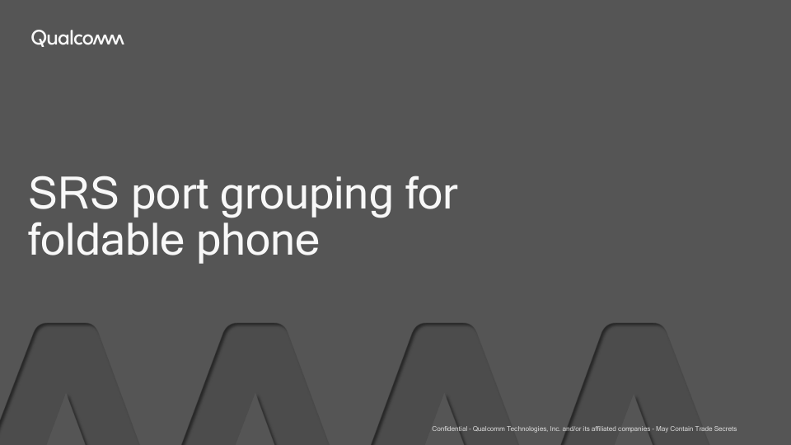

Image from Slide 2:

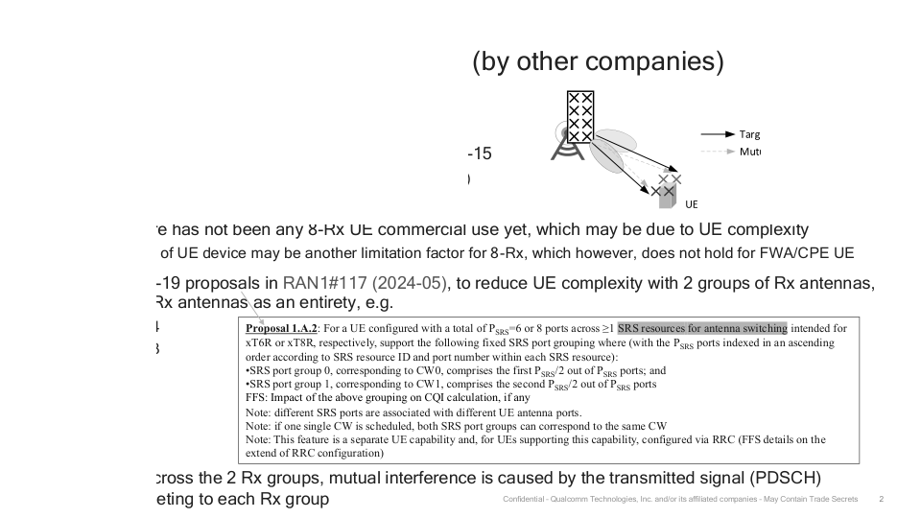

Image from Slide 3:

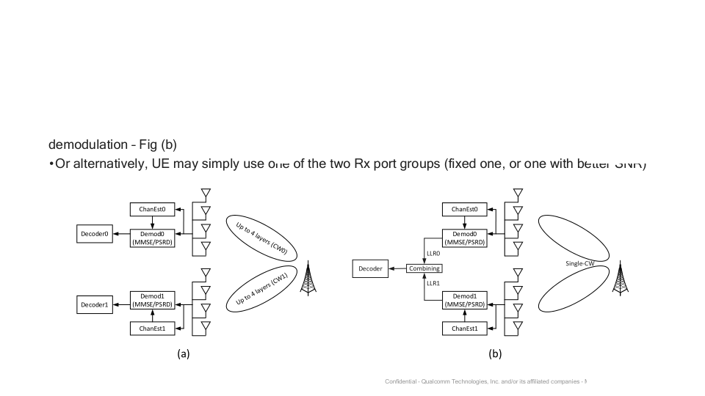

Image from Slide 6:

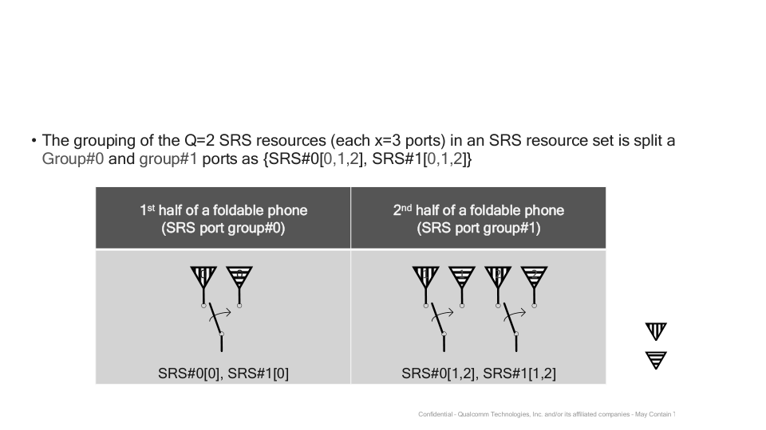

Image from Slide 7:

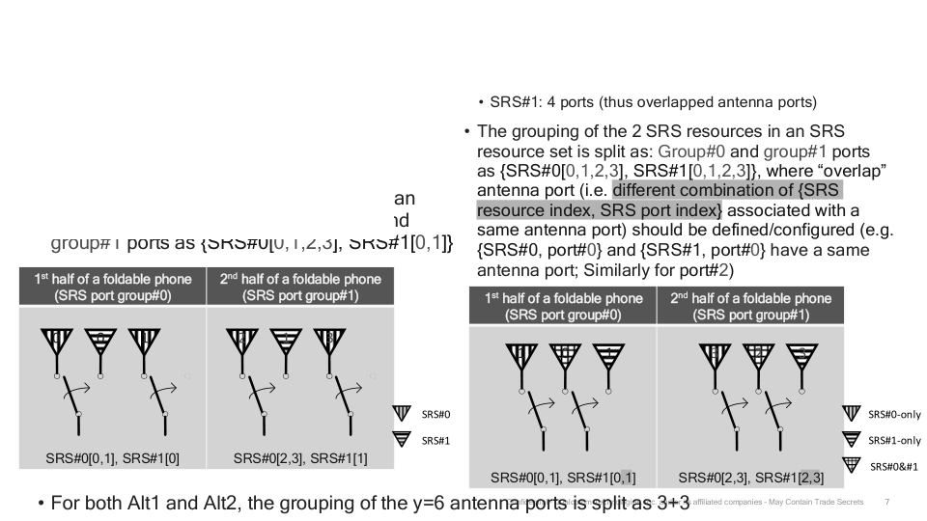

Image from Slide 8:

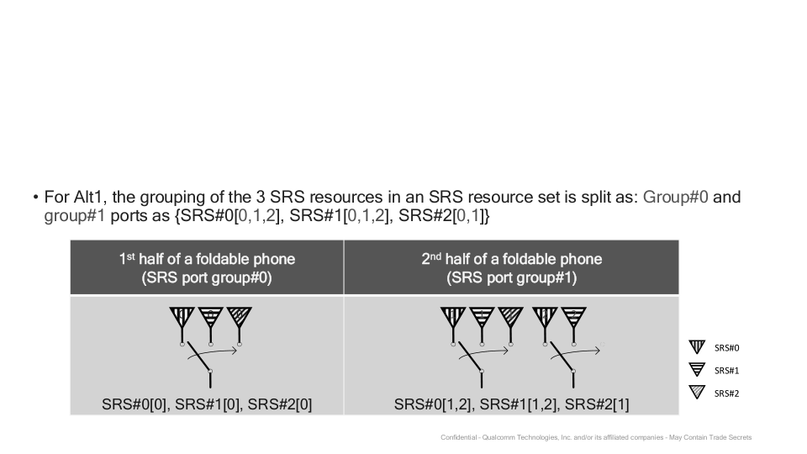

Image from Slide 9:

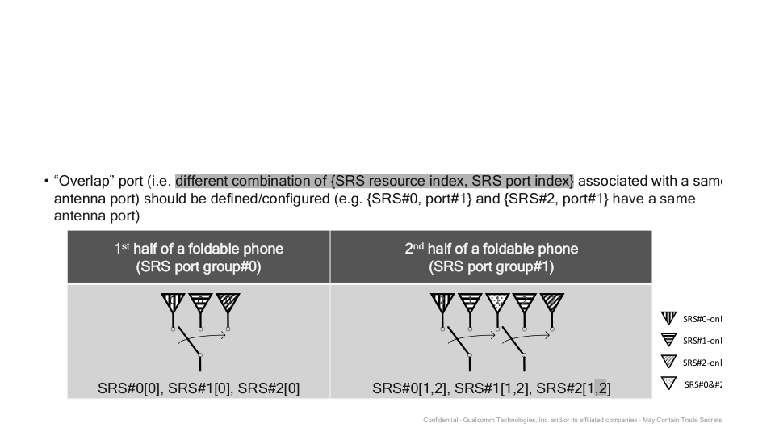

Image from Slide 10:

